**Calibrating New Servos in the Ground Station Software**

The antenna tracking software is specifically calibrated to the pair of servos on the ground station. Currently, the calibration is hard-coded into the *moveToTarget*() function in the main *Antenna_Tracker_Controls_GUI.py*.

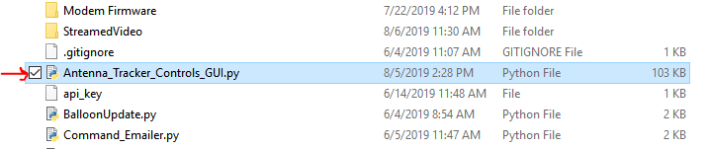

*The main file where that you need to edit (above).*

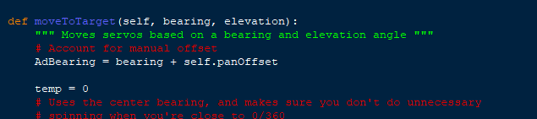

*The desired function (above), along with the parts to edit (below).*

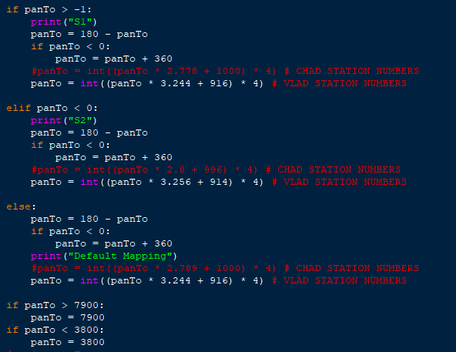

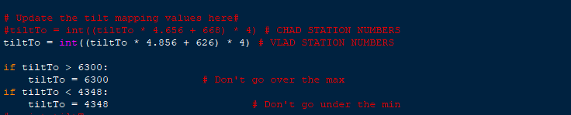

The servo values are selected using a linearization model built from testing a few angle-value pairs on the servos. You will want to edit the equations used to find *panTo* and *tiltTo*. In these pictures, there are two sets of equations, one for the Chad and Vlad stations, respectively. The multiplicand and constant in the equation can be found by running the *mapCalc.py* file.

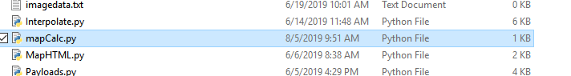

Open the *mapCalc.py* file

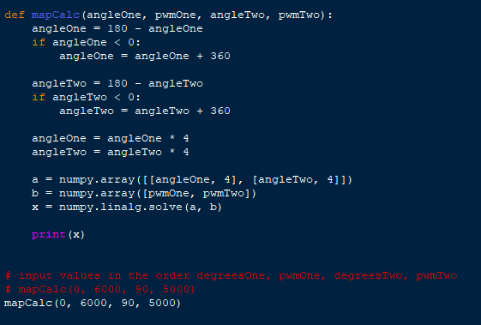

Replace the values in the *mapCalc*() function call with a pair of measured angles and the PWM values used to turn the servos there. (You can use the MAESTRO software to control the servos and set the PWM value, but you have to multiply the value by 4 because it is only 8-bit). Then, run the file and put these values into the panTo and tiltTo equations. :)

